

**COLLEGE OF COMPUTER AND INFORMATION SCIENCE**

**________________________________________________**

**Academic Year 2022 – 2023**

# PRACTICUM REPORT DOCUMENT

Cyrruz John N. Varquez

Submitted to the faculty of Malayan Colleges Laguna

In Partial Fulfillment of the Requirements for the Degree of

Bachelor of Science in Information Technology

**JUNE 2023**

# OVERVIEW

My name is Cyrruz John N. Varquez, and I am currently undertaking my practicum at the City Government of Biñan. This practicum is an essential part of my academic journey, allowing me to apply the knowledge and skills I have acquired throughout my studies. Over the course of my practicum, I am required to complete 486 hours of practical work, which presents an exciting opportunity for me to gain hands-on experience in a professional setting.

The internship experience at the City Government of Biñan has played a crucial role in developing the skills of the interns for their future careers. By actively participating in real-world projects and tasks, they have gained practical knowledge in project management, teamwork, and professional communication. Overall, the internship has enhanced their skill set and prepared them for success in their future professional endeavors.

The City Government of Biñan serves as the local governing body responsible for managing public services and implementing policies in the urbanized city of Biñan, Laguna. Their main goal is to provide efficient and responsive public service while striving to improve the well-being and prosperity of the residents. As part of their internship, individuals were assigned to different project teams: the Geographical Information System (GIS) team, the Biñan Website team, and the Youth Affairs and Sports Development Office (YASDO) team. Each team had specific roles for its members, including Quality Assurance, Documentation, UI Designer, and Developer.

# THE OUTPUT

## URL Shortening System

During the training, the students successfully built a short URL system that allows URLs to be converted into shorter versions. This system accepts long web addresses and returns a shortened URL as an output. The implementation of this method improves user experience by making it easier to share and distribute web links. With the short URL system in place, users may interact and navigate online resources more effectively and efficiently.

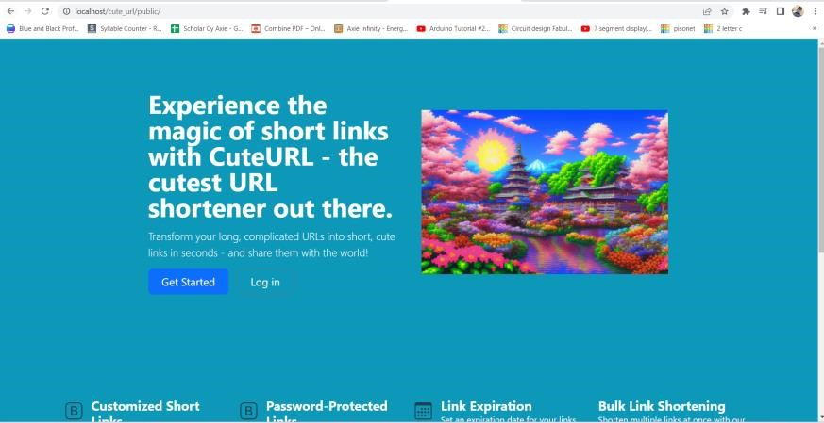

## Yasdo Portal

Roy, Jc, and I have been given the responsibility to construct the incredible Yasdo portal. This comprehensive project involves the creation of numerous webpages, including the SK portal and Lyorp portal, each tailored to cater to specific functionalities. Our primary objective is to simplify the access to Yasdo, ensuring a seamless and user-friendly experience for everyone. Below, you'll find a glimpse of our front-end designs, showcasing the thoughtfully crafted visuals that harmoniously blend aesthetics and functionality. These designs embody our unwavering dedication to making Yasdo accessible and visually appealing to users.

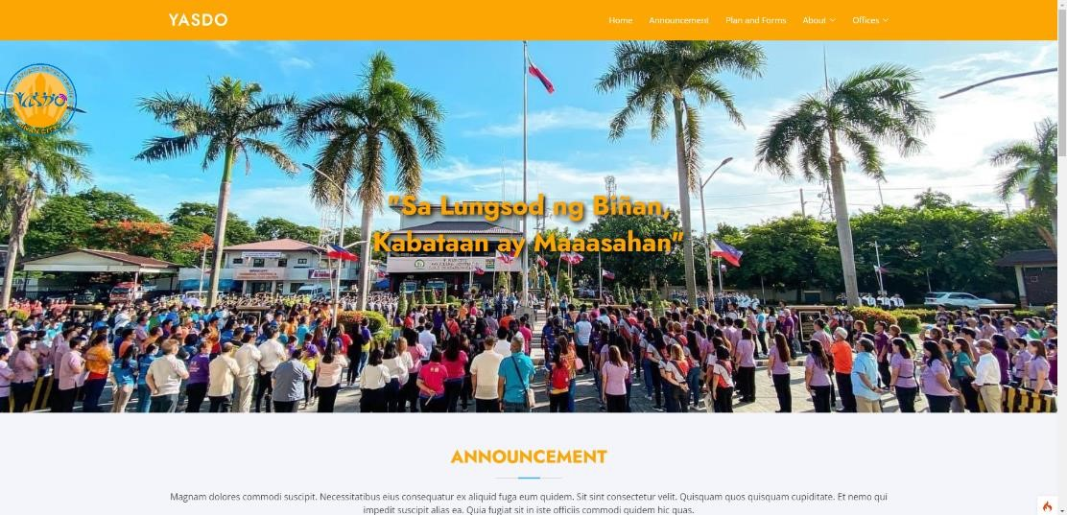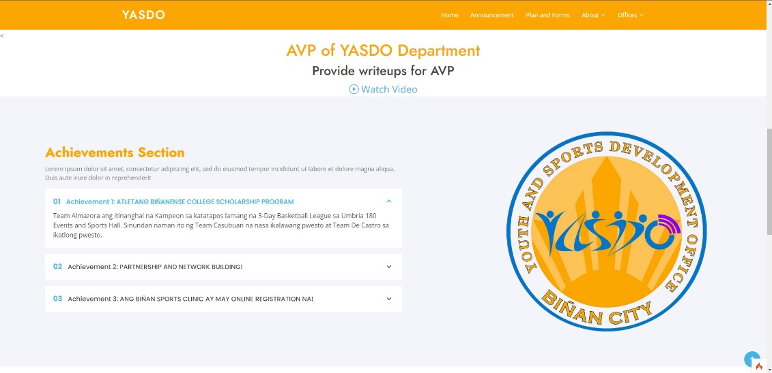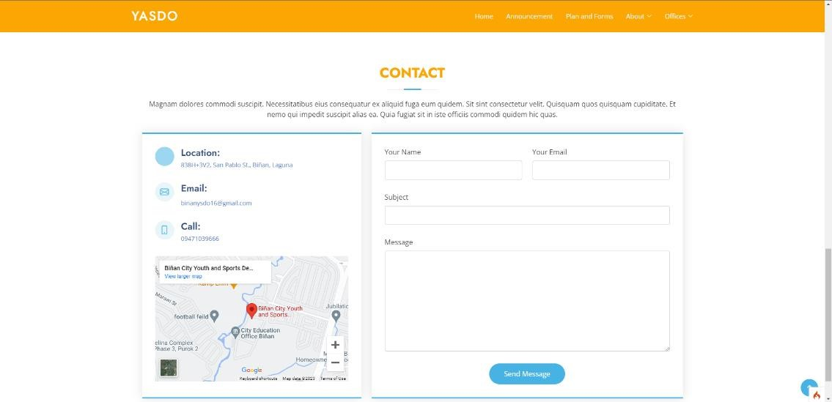

# SYNTHESIS

As an information technology graduate from MCL, I have had the opportunity to apply the knowledge and skills I acquired during my college years. Among the concepts that I have extensively utilized is the Model-View-Controller (MVC) architecture. Implementing MVC has allowed me to develop efficient and modular applications, streamlining the development process and improving code maintainability.

However, I must admit that adapting to new languages, particularly PHP, has been quite challenging for me as I did not have a prior background in it. During my internship, our mentors, Sir Pat and Sir Regie, introduced us to PHP (CodeIgniter) and Heidi SQL. This exposure proved to be a valuable learning experience as I was assigned to work as a backend developer.

Throughout the internship, I gained valuable insights not only in technical aspects but also in work ethics. The professional environment taught me the importance of punctuality, communication, and collaboration. These experiences have significantly enhanced my professionalism and have prepared me to excel in future professional endeavors.

Overall, my college education and internship have equipped me with the necessary skills to contribute effectively as an IT professional. I am confident in my ability to continue learning and adapting to new technologies and challenges that come my way.

# APPENDICES

## 1.0 Competency-Based CV

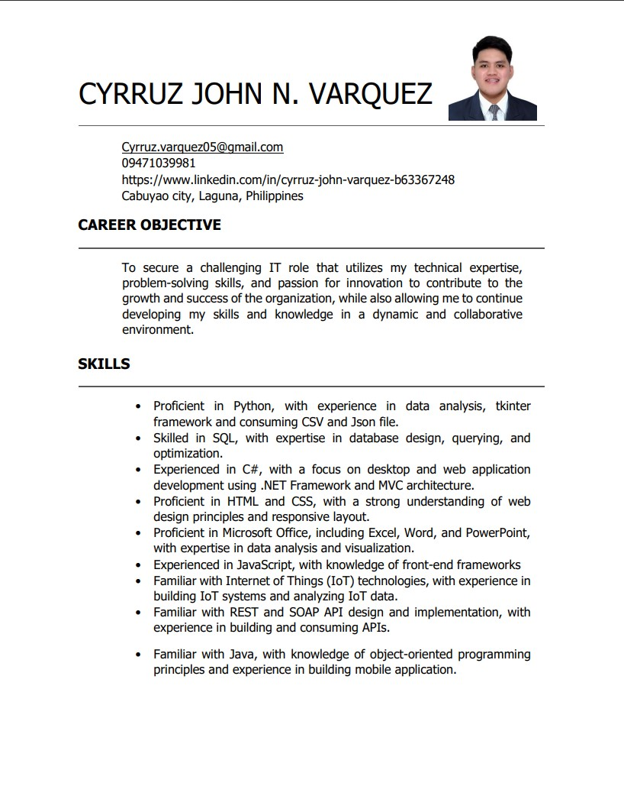

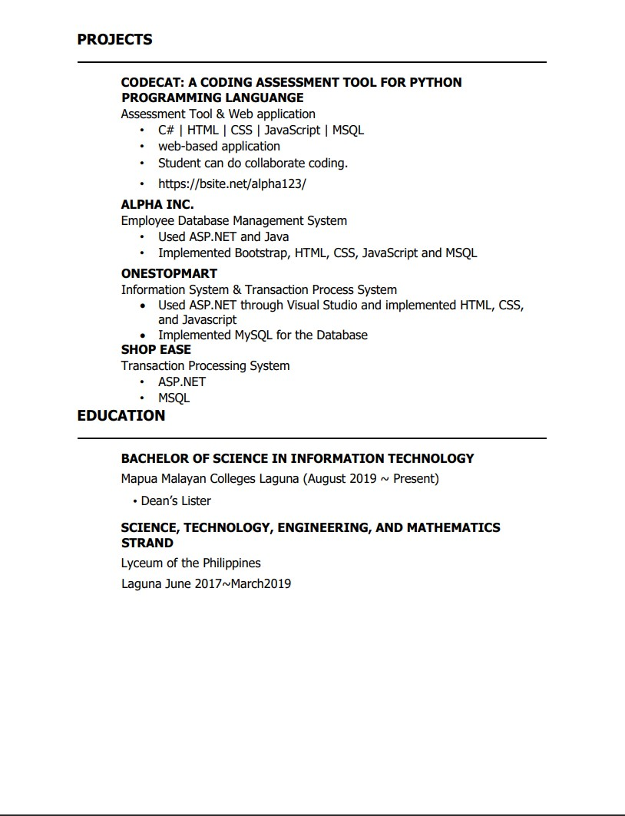

## Endorsement Letter

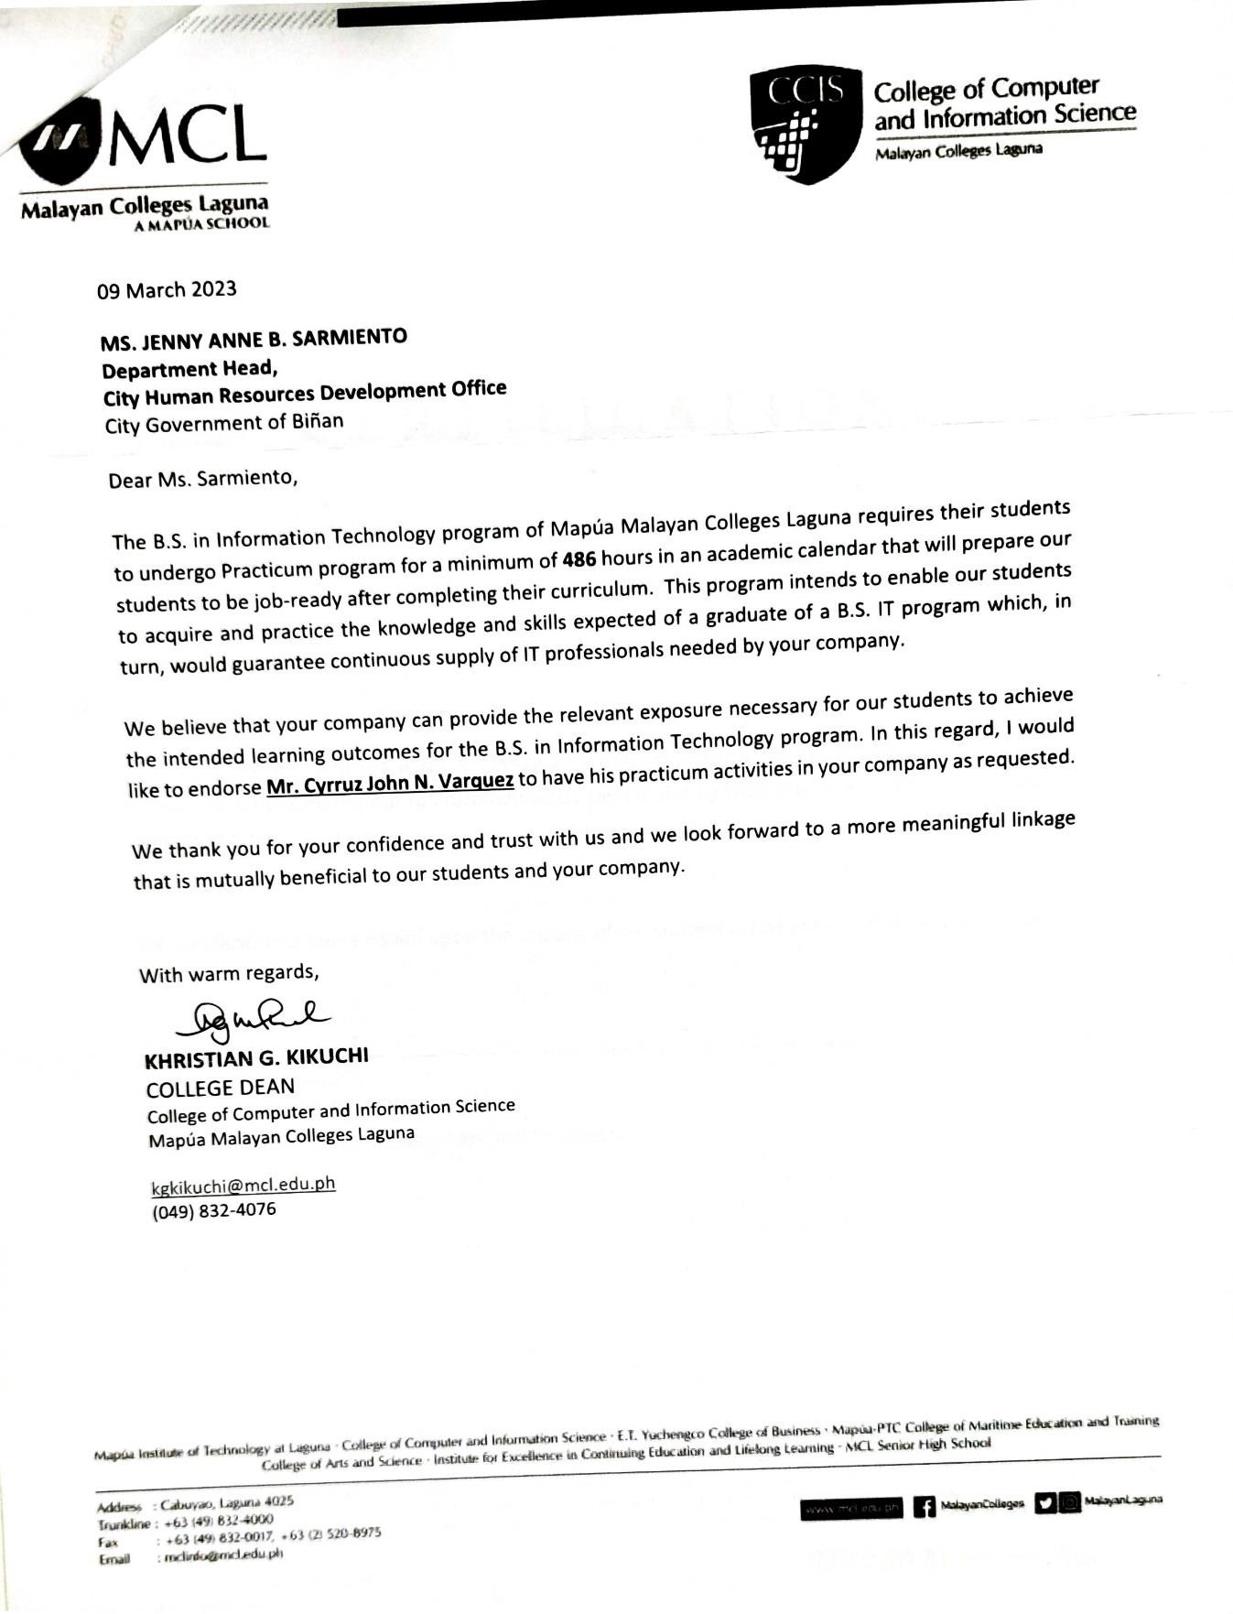

## Practicum Acceptance

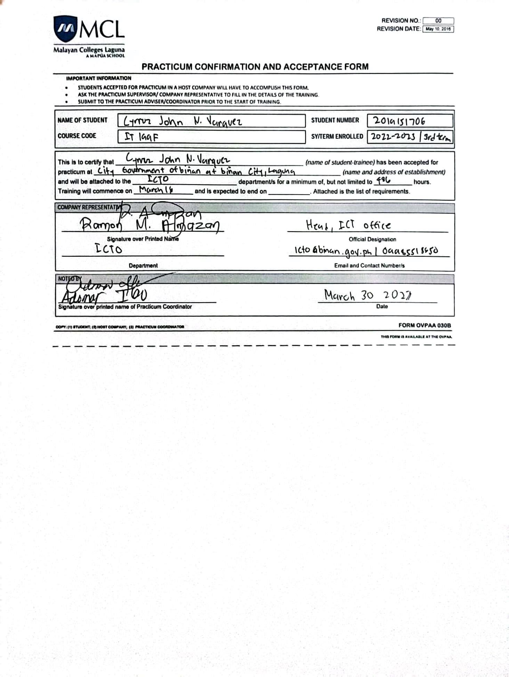

## Liability Waiver

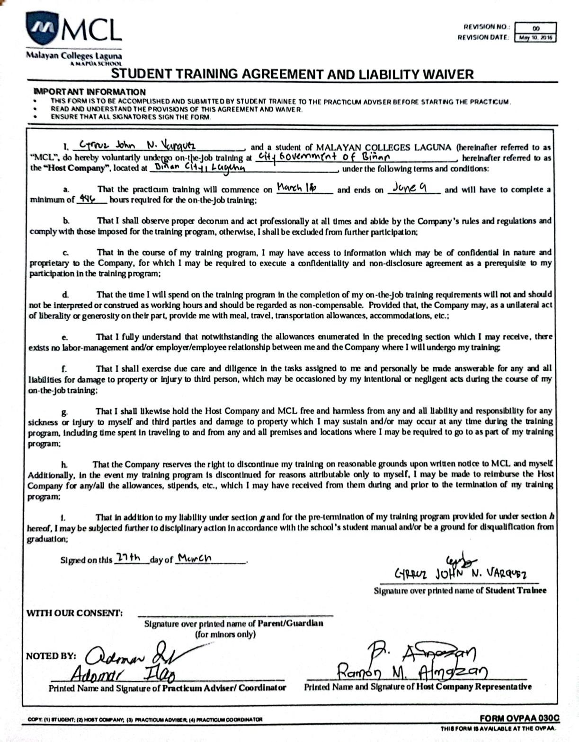

## Training Plan

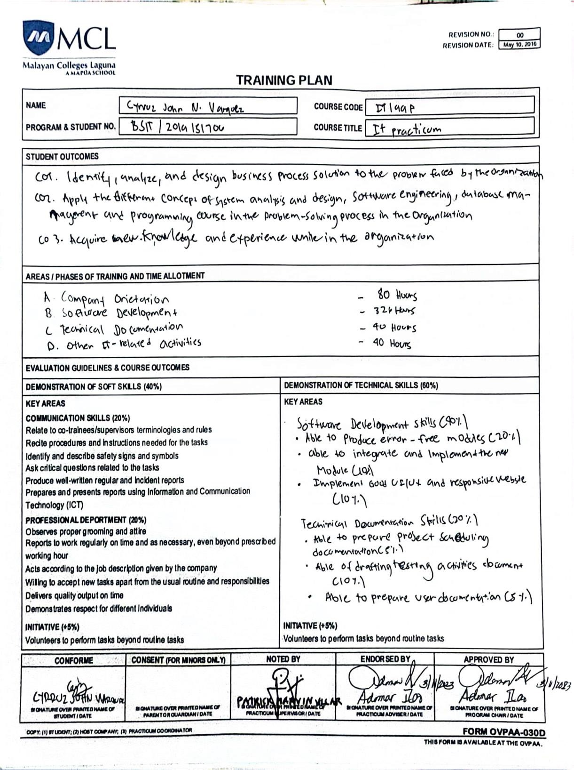

## Complete Weekly Journal

